Knowledge Acquisition Document

Version History
Version # | Date | Prepared/Revised By | Reason for Change
V 0.1 | 19/06/2019 | Rohit Das | Initial Version
V 1.0 | 11/07/2019 | Rohit Das | Baseline version. Reviewed by Kelvin and approved

Instructions:
- Please use the Font - Calibri (Body) and Font size as 11 across the document.
- Please save all the relevant attachments pertaining to the Application in Section 12: ‘Appendix’. Please embed the document in the same section and provide the link of the SharePoint or File Share in same section.
- Please ensure the alignment is appropriate for tables used within this document.
- Font used as Italic (in this document) is only for illustrative purpose. While writing the content, please remove Italic and use Font - Calibri (Body). Usage of Italic should be limited, unless its required/essential during Knowledge Transition.
- Section 8, 9 and 10 will have more focus during shadow phase though any inputs received during KT phase can still be captured.

Contents
1 Introduction 3
1.1 Purpose 3
2 Stakeholders, SMEs and Zensar Resources 3
3 Knowledge Transfer 3
4 Functional Overview 3
4.1 Application Overview 3
4.2 Description 3
4.3 Application Functionalities Used 3
4.4 Critical Modules 7
5 Tools 7
6 Technical Overview 7
6.1 Application Architecture diagram 7
6.2 Source Code 7
6.2.1 Repository details 7
6.3 Databases Used 8
6.4 Jobs and Schedulers 8
7 Glossary 8
8 Appendix 8
9 Approvals / Sign offs 8

Introduction

Purpose
The purpose of this document is to provide a functional and technical overview of the activities related to Client Interface Charging. This document will be used as reference by the application management team. It will be updated and refined continuously during the lifespan of the system.

Stakeholders, SMEs and Zensar Resources

Stakeholders/ SMEs (Client end)
Name | Role |  | Phone/Email | Department
Kelvin Jacobs | Senior Analyst Programmer |  | KJacobs@OLDMUTUAL.com | IT department – Closed Book
Sedick Parker | Senior Business Analyst |  | SParker9@OLDMUTUAL.com | IT department – Closed Book

Zensar’s Team
Team member Name |  | Role | Phone/Email | Department
Rohit Das |  | Lead Analyst Programmer |  | IT department – Closed Book Transition

Knowledge Transfer

Knowledge Transfer & Reverse KT Planning
Mode of Transition | Webex sessions, Face to Face, Documents, trainings, etc.
Duration of Knowledge Transfer | 12 Weeks of KT
Duration of Shadow and Reverse Shadow | 4 Weeks of Shadow  3 Weeks of Reverse Shadow  1 Week of Readiness

Functional Overview

Application Overview
Client Charging is process of changing policy status. It is an interface on its own.
It is the product of Client Charging.
It is similar to Adhoc request where the request comes from the business to update/change a policy number or status of the confiles.

It is business driven and confiles are critical to change the status or update it as soon as possible.

Description
Key attributes of the application
Sr. No. | Interface Name | Process Description (short) | Appendix Reference
1 | Client Charging – Changing Policy Status | Performed as when request comes like Adhoc Request | 8.1

Application Functionalities Used
Client Charging is performed as on when the request comes. It is like Adhoc request.

The Client Charging/Changing the policy status occurs in following steps:

- OM receives email from the business in order to the change the policy status or to add a new policy to an existing Confile.

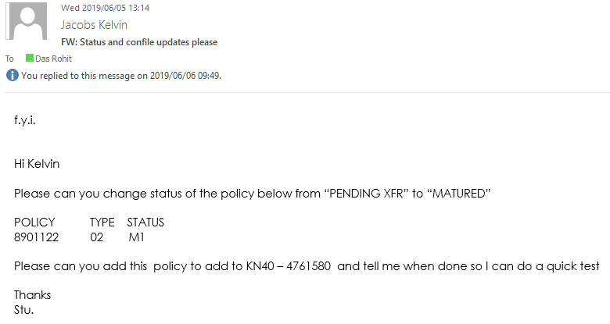

- Here, as we can see the above mail, there are two requests that needs to be done.
- Change status of policy from ‘Pending XFR’ to ‘Matured’
- Add a new policy number to the confile KN40

- In order to change the policy status, select option 7.2 in TSOB region and access the library CFGIBS.WR.PARMLIB

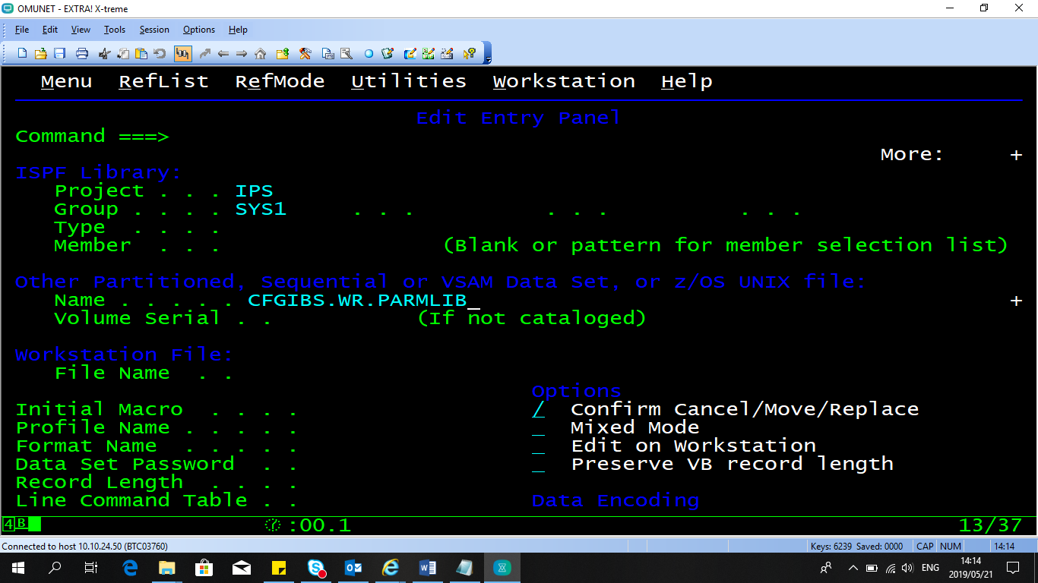

CFGIBS.WR is the client database where the policy updatation takes place.

- To check for the policy type, Select LIFE option from the main menu.

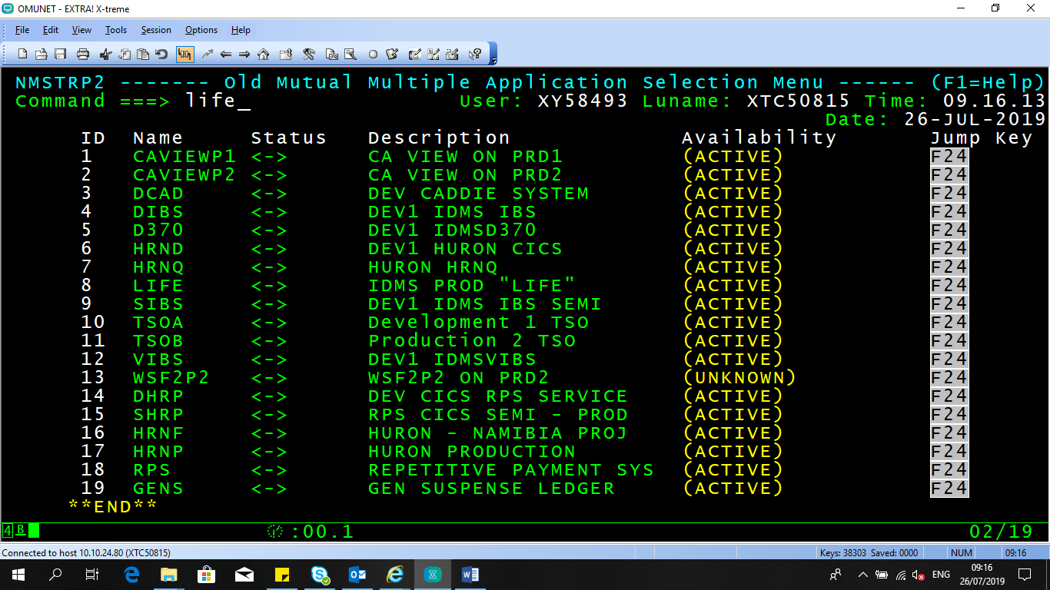

- Select Client Enquires(CE) from the LIFE menu

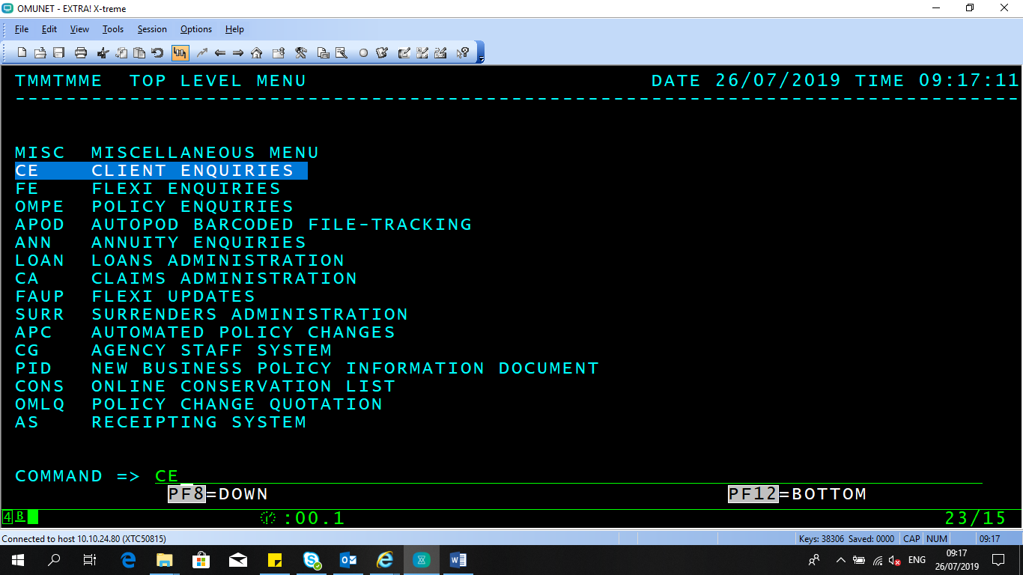

- Select CBAS to fetch the basic details of the client

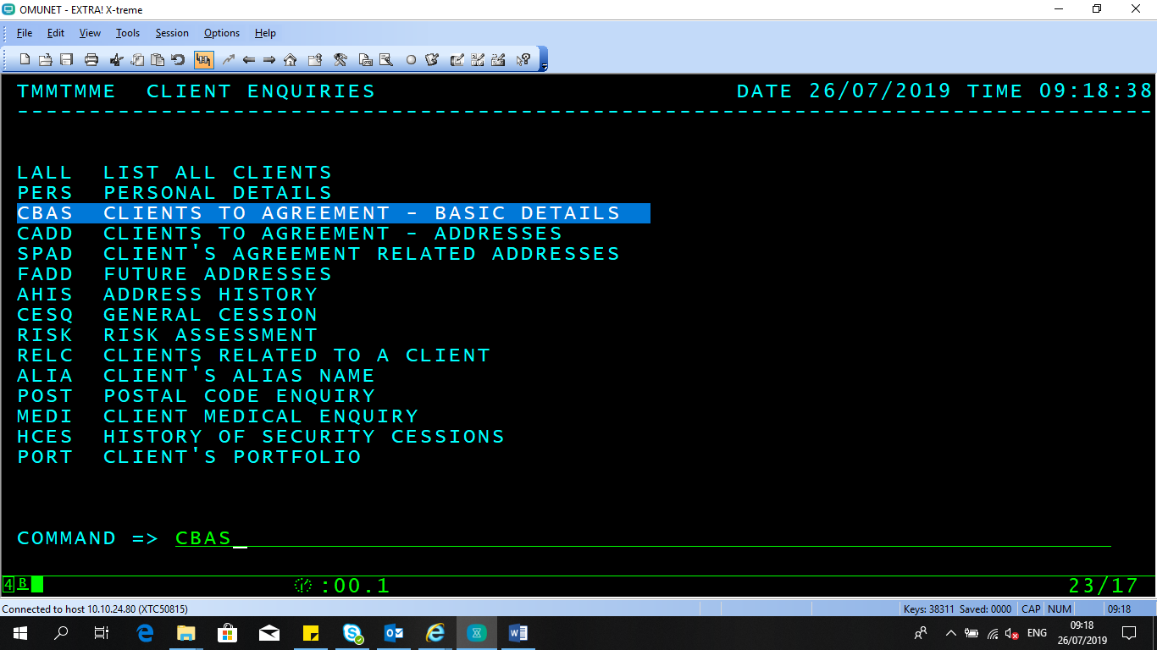

- Enter the policy number and fetch the basic details such as policy type and agreement type. Refer appendix 8.2 for policy information

- Insert the 9-digit policy number along with the Type & Status, if policy number is less, precede it with zeros in to the parmlib WRPOLST

The general format of policy number is always a 9-digit format, but when we received the mail from the customer it might be focusing on the important digits of the policy therefore it is necessary to precede the policy number with zeros.

- The structure of the parm is as below in program ABCSTUPD

The program ABCSTUPD picks the parm file as an input and the structure is maintained with the policy number received from the business user.

- Once the parmlib is updated with the new policy change status, the task is complete

- The job XWRD025 will pick up this parmlib during the daily batch run and update it to PROD.

- The program ABCSTUPD will update the policy status from the parameter file

- After doing the policy update, this job will also clear the parmlib WRPOLST to empty so that it stays always refreshed (Clears input file) and this completes the process of changing/updating policy status

- In order to add new policy to the confile KN40, it follows the same process as an Adhoc Request.

- First retrieve the confile KN40 from the PROD library in to your personal library, in order to do that go to TSO DMCMENU

- Retrieve the element using the option 3.3.

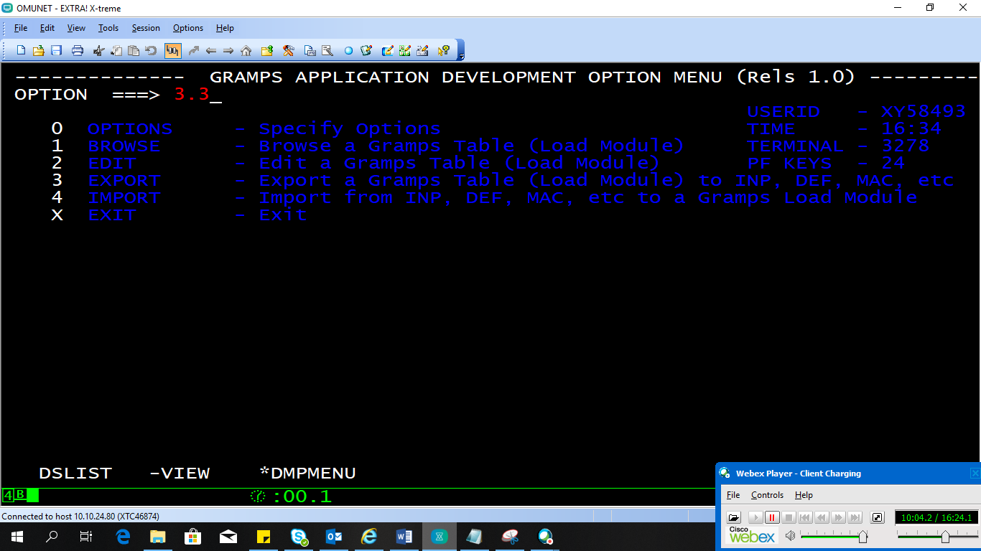

- Retrieve from the SIBS library (SYS1.IBS.GRAMPS.LOAD) in to your personal library/dataset

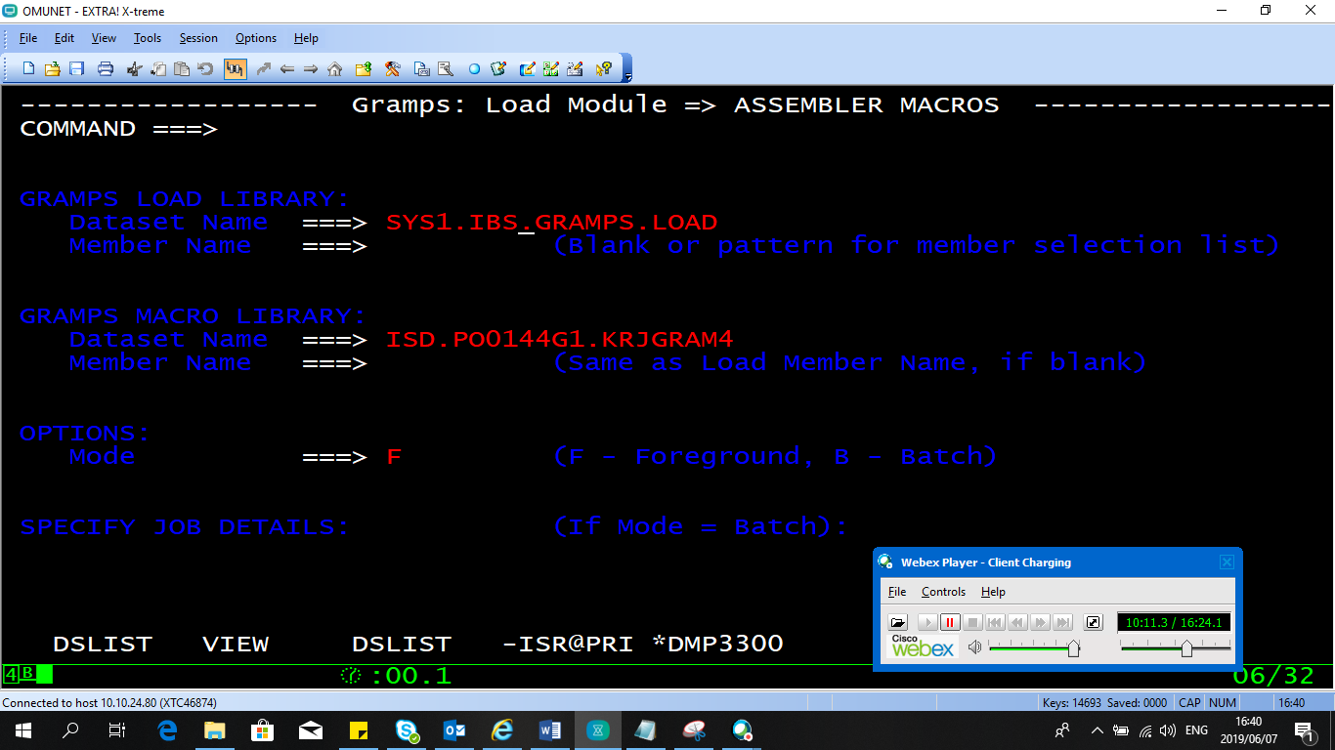

- Once the element is retrieved in to your personal library, update the confile KN40 with the new policy number.

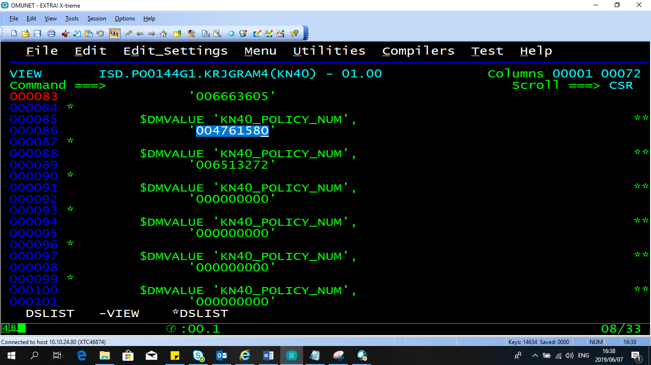

Since the confile is already in macro format, we don’t need to do any conversion of input to macro format.

- Once updated, we compile it using to SIBS and update the parmlib with KN40 as per adhoc request process.

This completes the addition of policy in to confile KN40.

Requests:
CBA9720323- Status to be amended to GCF: Policy 6001242 BDL/WYLE PW LABUSCHAGNE

For these change codes that give you a description in WR client are in CFGDIBS.PROD.LIB(WRGROFFB)

GCF- 3R
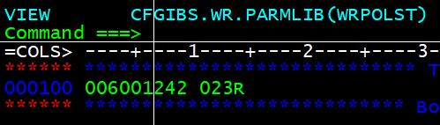

Critical Modules
All the Client Charging are critical as all the confile rates are market driven.

Tools
Below are the Mainframe/web tools which are widely used:
GRAMPS – To calculate prices and interest rates.
Client Database – IDMS/WR
DMCMENU - Compiler

Technical Overview

Application Architecture diagram

Sr. No. | Technology Used | Version Description
1 | Mainframe, COBOL Framework | ZOS – Version 02.03.00
2 | IDMS Database
3 | Security | RACF
4 | JCL’s for batch operations | Mainframe Jobs

Source Code

Repository details

Repository Name | Description
Cobol Source code Library | Below are the libraries where complete jobs, copybooks resides.
Copybooks | SHRXIBS.PROD.COPYLIB (KN40)
Library | CFGIBS.WR.PARMLIB
Job | XWRD025
Program | ABCSTUPD
Region | TSOB
PARMLIB | WRPOLST

Databases Used
Databases Names | Environment
LD01 Database , IDMS,WR | COBOL

Jobs and Schedulers
XWRD025 is the daily job which runs and updates the policy change.

Glossary
Master Glossary
# | Term | Definition
1. | WR | Client Database
2. | SYS1.IBS.GRAMPS.LOAD | Prod library to retrieve
3. | TSOB | Region where all the policy change updates takes place

Appendix
# | Topic | Subject | Definition | Link
8.1 | Customer Mail | Policy Change | Mail received from business in order to change policy state
8.2 | Client Policy Status Check | Policy Type | Policy status check pdf

Approvals / Sign offs

Approver Name | Signature/Electronic Approval | Date

